You may be required to apply for an EIN for banking purposes. The link below and screen shots are to assist you with the process.

<https://sa.www4.irs.gov/modiein/individual/index.jsp>

Select Begin Application:

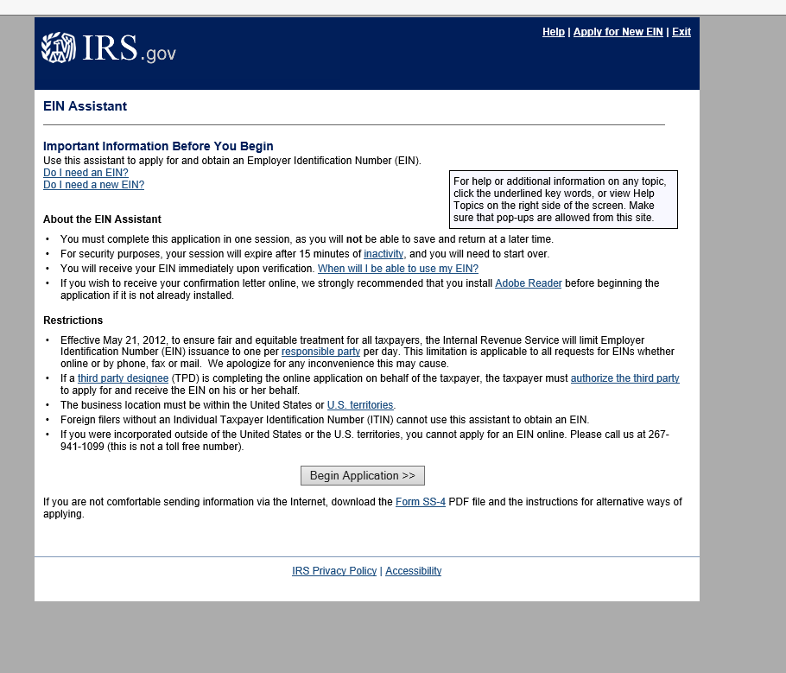

Select View Additional Types

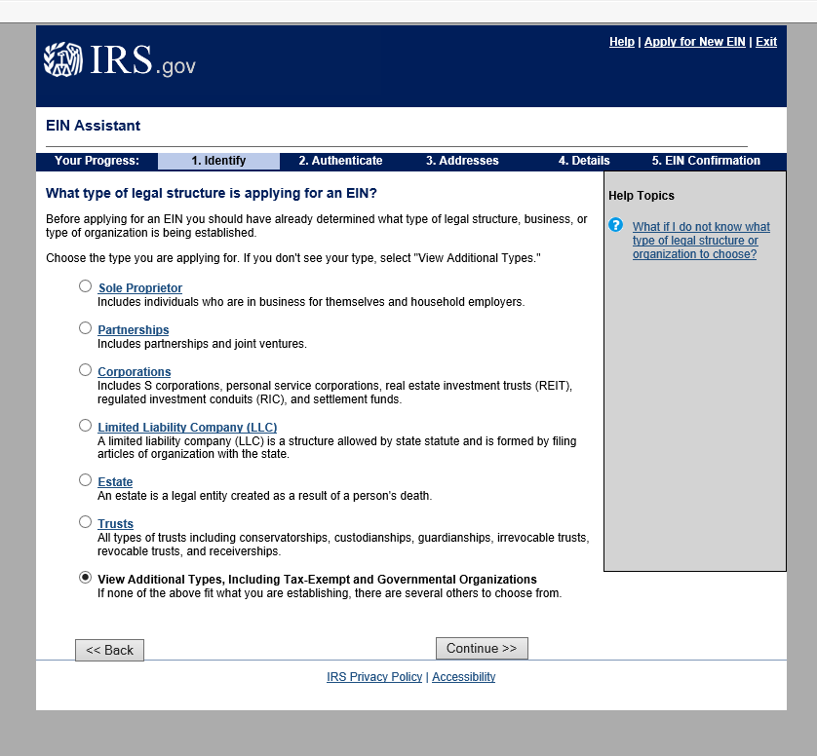

Select the applicable affliation for which you are applying for:

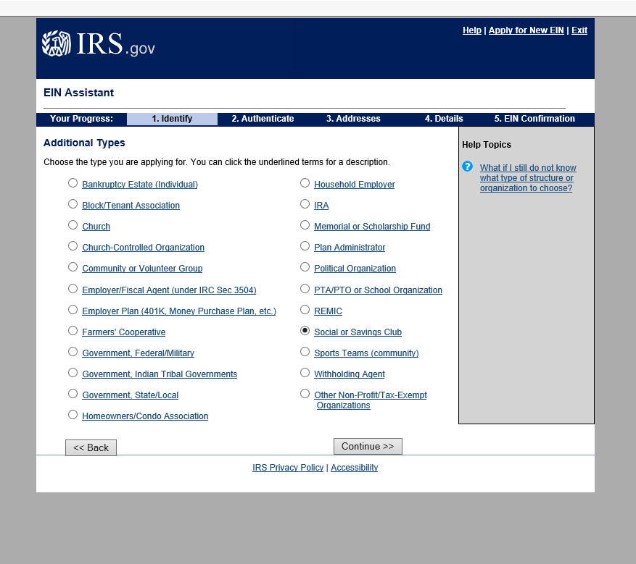

Select Continue

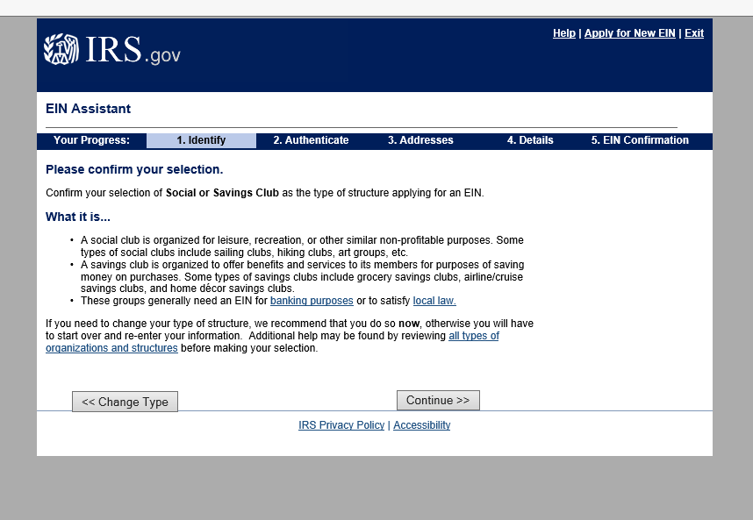

Fill out information and continue until process is completed – keep/print confirmation letter.

